Phase 3 CUSTOM OBJECT CREATION

**Objects Created :**

We created 8 custom objects to represent core entities in restaurant operations:

* **Menu Category, Menu Item** → structure the menu for customers.
* **Inventory Item** → track food ingredients and supplies.
* **Restaurant Order, Order Line Item** → capture customer orders in detail.
* **Purchase Order, PO Line Item** → manage procurement from suppliers.
* **Recipe Ingredient** → link menu items with inventory usage.

This ensures all aspects of the restaurant workflow (menu, inventory, orders, procurement) are digitally represented.

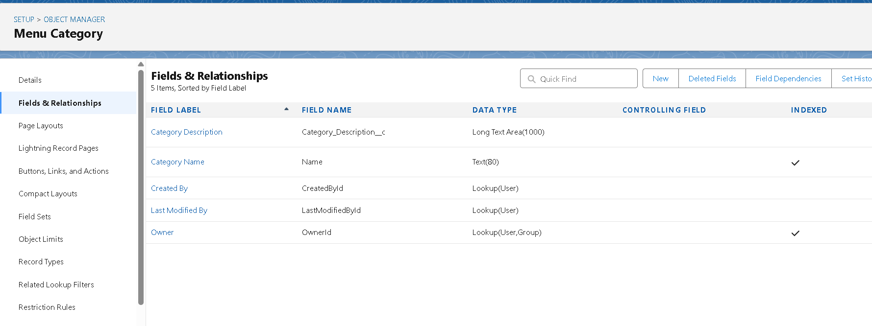

**Relationships Established**

To maintain data integrity and process flow, key relationships were implemented:

* **Master-Detail** ensures dependent records (Menu Items, Order Line Items, PO Line Items) roll up to their parent objects.
* **Junction Object (Recipe Ingredient)** enables many-to-many mapping between Menu Items and Inventory Items.
* **Lookup Relationships** to Customer, Supplier, and Server provide flexibility without strict dependency.
* This structure allows for accurate reporting and prevents data fragmentation.

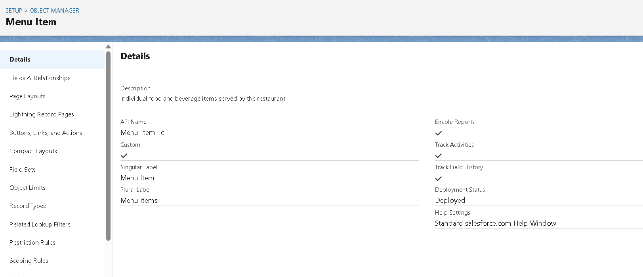

**Fields Added (45+ total fields)**

Custom fields were created across objects to capture operational details such as pricing, quantities, preparation times, supplier details, and dietary info. These fields ensure users have all necessary information directly available within Salesforce.

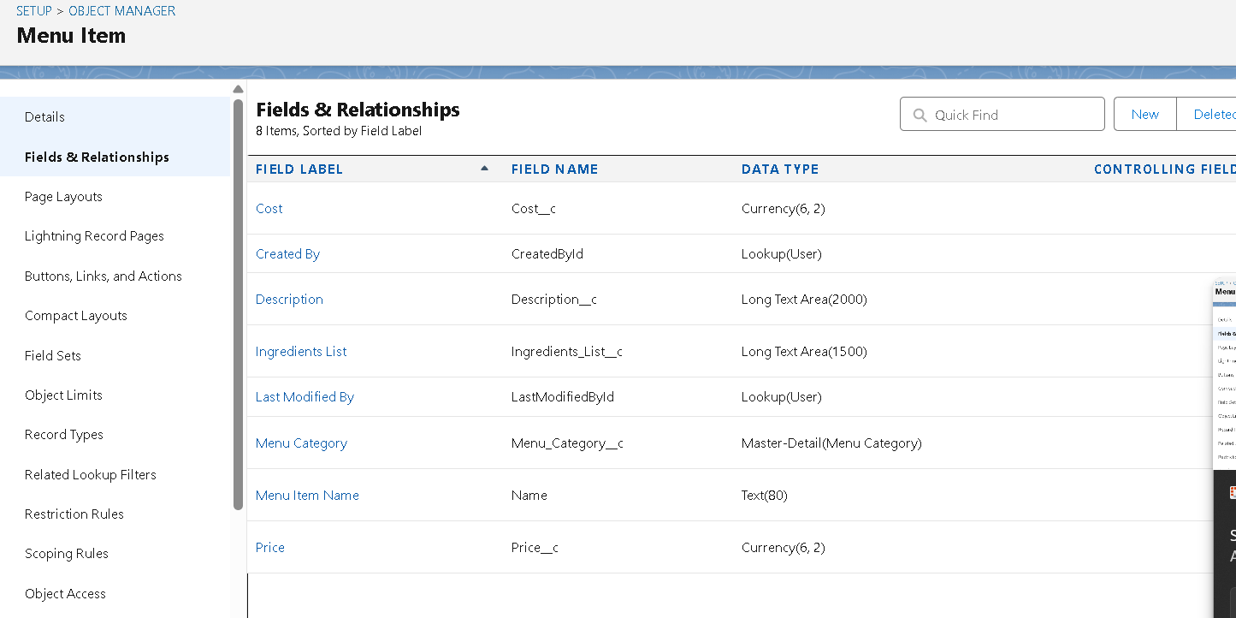

**Record Types**

Record Types help tailor the system for different business needs:

* **Account** → split into *Customer* and *Supplier* to distinguish between diners and vendors.
* **Inventory Item** → split into *Food Ingredient* and *Supply Item* to separate perishables from general supplies.

This enables customized page layouts, picklists, and business processes depending on context.

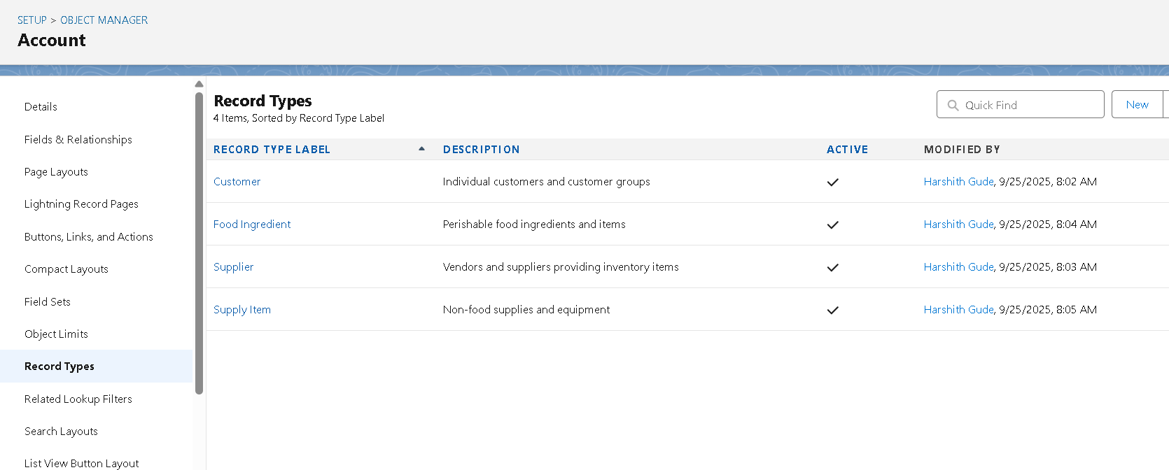

**Page Layouts**

Page layouts were customized for each profile to simplify user interaction. For example:

* **Servers** see only relevant customer/order details.
* **Inventory staff** see supplier and stock information.
* **Managers** see financial and operational summaries.

This reduces clutter and improves adoption.

**Compact Layouts**

Compact layouts were built for mobile users, displaying the most important fields (like Customer Name, Table, Order Status, Quantity) at a glance. This helps servers and managers work efficiently on-the-go.

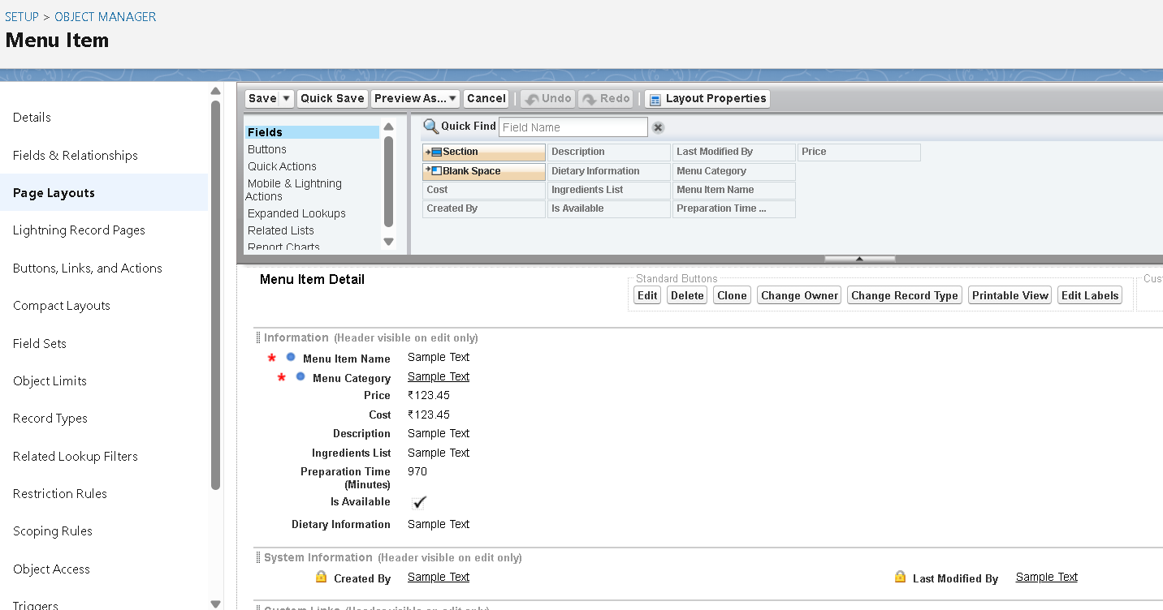

**Data Model Testing**

To verify that the data model works as intended, **sample records** were created across key custom objects. This ensures relationships, fields, and workflows function correctly in real scenarios.

